Mauricio Azcona

CSCI 3334

Professor Quweider

20 April 2018

Ticket Citation Screenshots (Database)

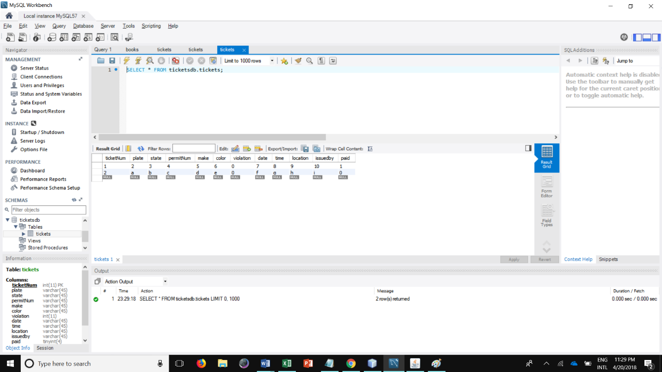

Tickets database

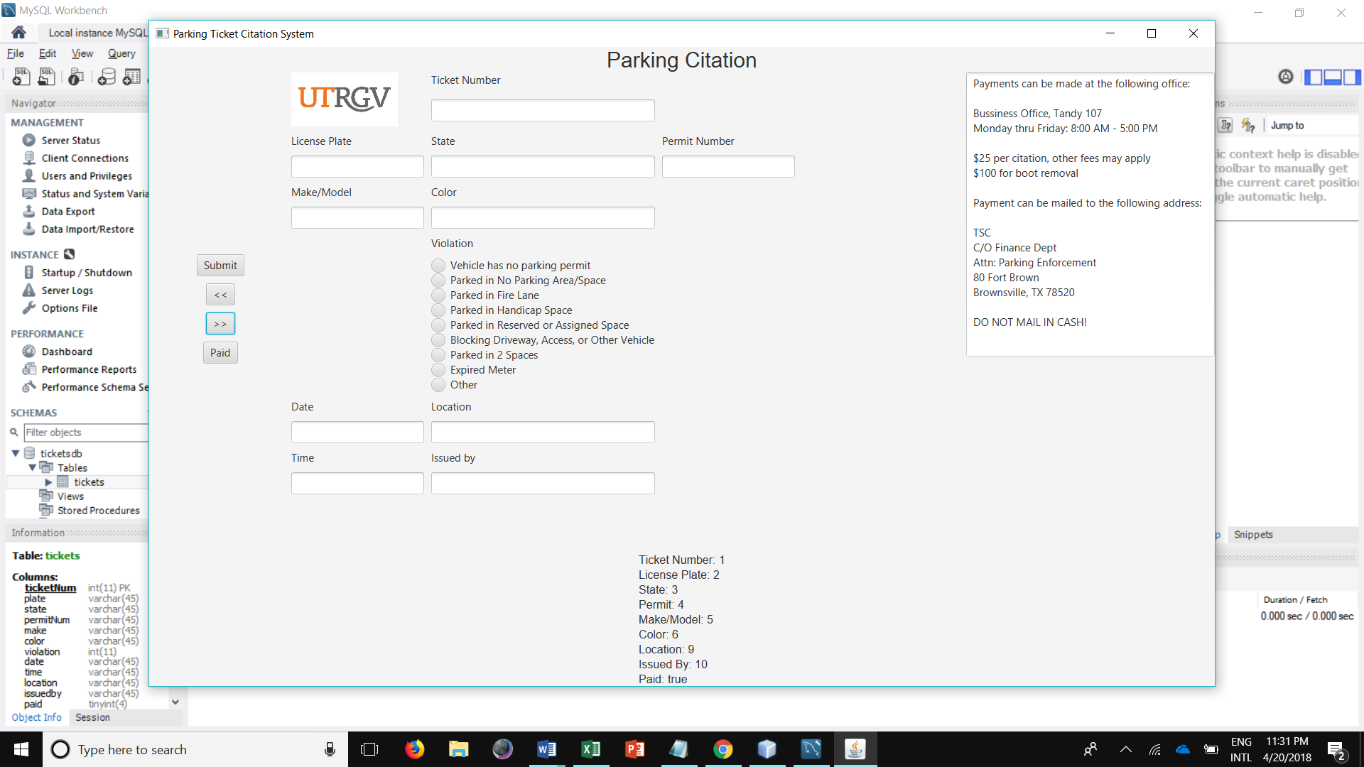

GUI with displayed ticket on bottom